Feltman® Eyes resource order form for Victoria
The Feltman® eyes resource kit is intended to be used with the Feltman® resource and consists of:
- Felt eye attachment
- 2 x retina image discs (1 x healthy, 1 x diabetic retinopathy)
- Laminated cards for demonstration
- Key messages booklet
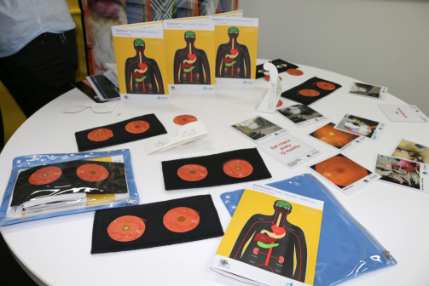

Description | No. of Units | TOTAL
Feltman® Eyes
 | Total
Date:
Name:
Position/Job Title:
Organisation
Telephone Number:
Email Address:
Postal Address:

Post, fax or email your completed form to:
Aboriginal and Cultural Diversity Team
Diabetes Victoria
Post: 570 Elizabeth St, Melbourne VIC 3000
Fax: 03 9667 1778
Email: culturaldiversity@diabetesvic.org.au

