Feltman® Eyes resource order form for Interstate Organisations
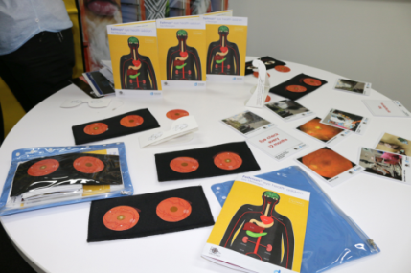
The Feltman® eyes resource kit is intended to be used with the Feltman® resource and consists of:
- Felt eye attachment
- 2 x retina image discs (1 x healthy,
1 x diabetic retinopathy)
- Laminated cards for demonstration
- Key messages booklet

Date ____________________
Name __________________________________________________________
Organisation __________________________________________________________
Telephone Number __________________________________________________________
Email Address __________________________________________________________
Postal Address __________________________________________________________
__________________________________________________________
Description | Unit Price | No. of Units | TOTAL
Feltman® Eyes | $38 (Including GST and postage)
 |  | Total

Payment Details Credit Card Details
□ Visa □ MasterCard
Card Number : _____________________________________________
Cardholder Name: ___________________________________________
Expiry Date : _____________________________________________
CVV : _____________________________________________
Amount : ______________________________________________
Signature : ______________________________________________

Post, fax or email your completed form with your payment to:
Aboriginal and Cultural Diversity Team
Diabetes Victoria
Post: 570 Elizabeth St, Melbourne VIC 3000
Fax: 03 9667 1778
Email: culturaldiversity@diabetesvic.org.au
Your order and receipt will be posted on receipt of payment

